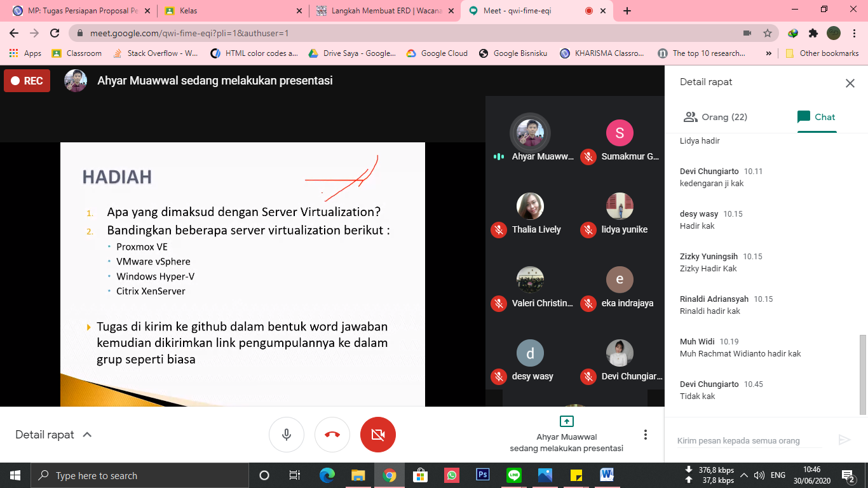 Tugas Pertemuan 10 Cloud Computing!!!!

Stefany Yason-51017018(Cloud Computing)